**USER MANUAL**

**e-Award (Acceptance of Award by the Supplier)**

**Electronic Government Procurement System – eGP System**

***Provider:*** *Joint Venture of Tenece Professionals and Nextenders (India) Pvt. Ltd.*

*The information contained in this document is private and confidential and intended only for the use of eGP System of PRAZ. The contents of this documents should not be used before prior authorization of PRAZ.*

**Table of Contents**

Getting Started 4

Part I. System Log-In and Credentials 4

Part II. Forgot Password and Change Password 4

Part III. Supplier Accepting the Award Notice 4

**Acronyms: -**

|  |  |
| --- | --- |
| EC | Evaluation Committee |
| BOT | Bid Opening Team |
| QBS | Quality Based Selection |
| PMU | Procurement Management Unity |
| BEC | Bid Evaluation Committee |

**Note:** After Bid Evaluation, the user having award creation access level has to create the award to award the shortlisted/qualified supplier to get into a contract with the entity. The supplier user needs to accept the award notice sent by the entity.

**Getting Started**

This section will illustrate the step-by- step walkthrough of the system from initiation trough exit. The logical arrangement of the information shall enable the Procuring Entity to fully understand the flow and functionality of the system.

**Part I. System Log-In and Credentials**

Please refer **User Manual - Manage Profile for Procuring Entity**.

**Part II. Forgot Password and Change Password**

Please refer **User Manual - Manage Profile for Procuring Entity.**

**Part III. Supplier Accepting the Award Notice**

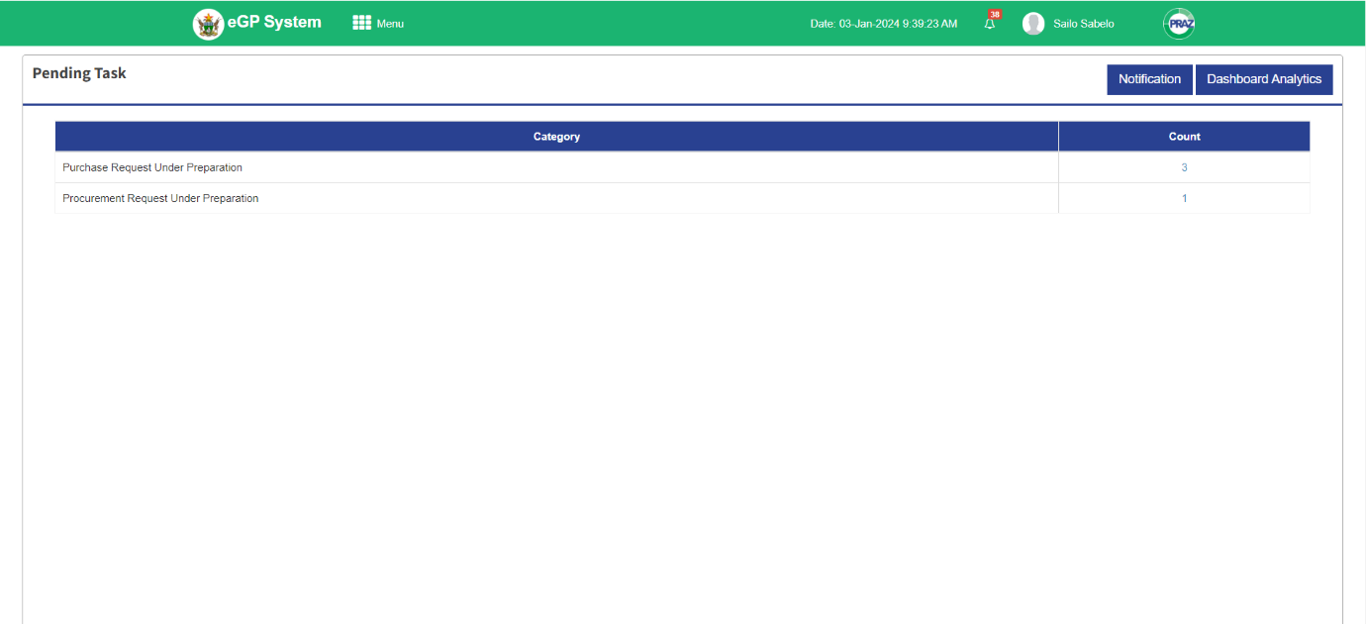**Step 1: Supplier** Log in to the system by selecting user type as supplier, username and password. The system directs the user to the dashboard with the pending task.

**Step 2:** Click **Menu** at the top left corner of the dashboard, the system responds with the Submenus for the Supplier.

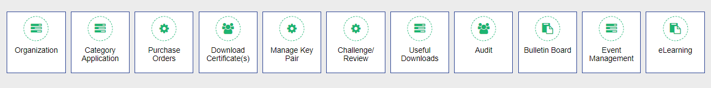

**Step 3:** The next step for the Supplier is to click **Even Management**, the system responds with the event management page with options Invitation to Bid, My Opportunities and My Award Notices.

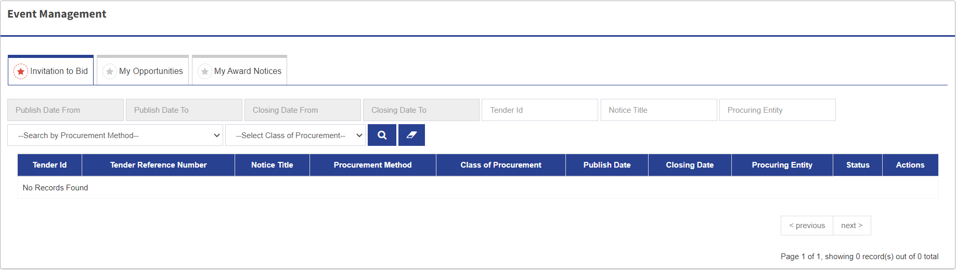

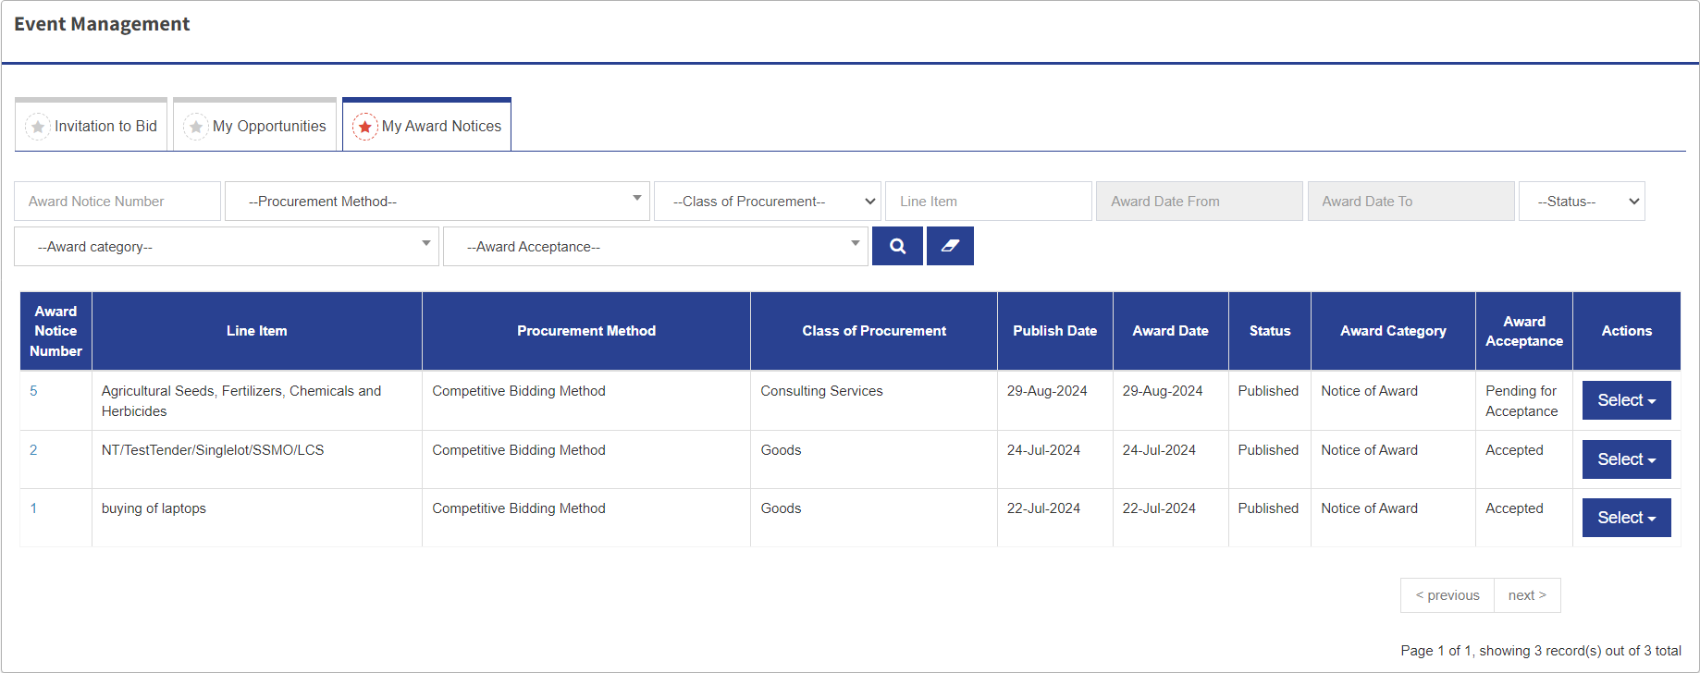**Step 4:** To proceed click **My Award Notices**, the system responds with the list of award notices for the Supplier to accept.

**Step 5:** From the list of award notices, select the award to be approved. To proceed click **Select** dropdown and under the dropdown there are two options View Award and View Comments. Click **View Award** the system responds with the Award Notice from

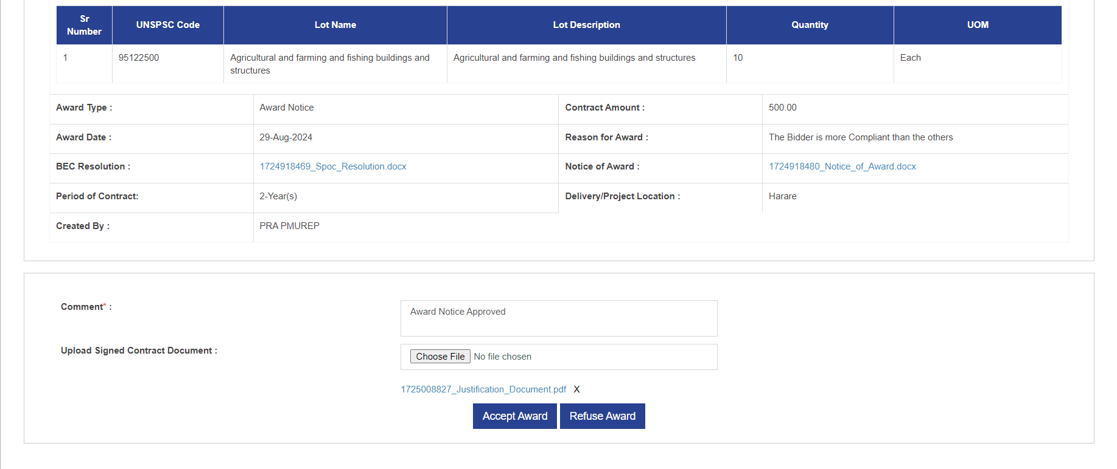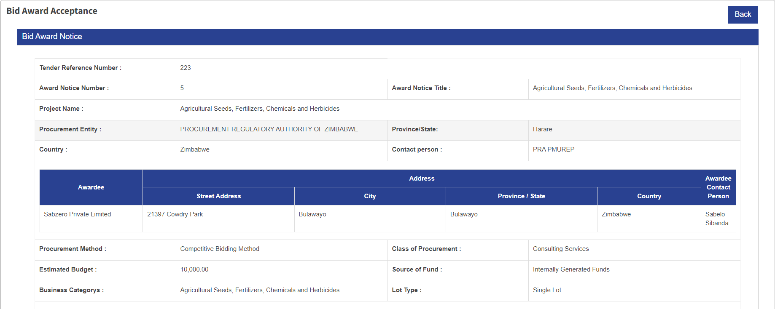



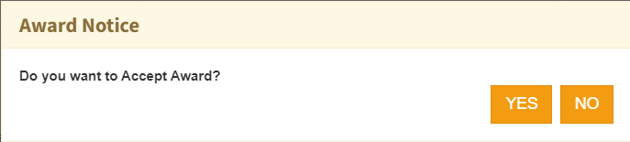**Step 6:** The Supplier has to go through the Award Notice before Accepting. That is also the stage where Signed Contract Document uploaded. To accept the Award click **Accept Award** and the system responds with a confirmation message “Do you want to Accept Award?”

**Step 7:** If yes click YES and the system responds with the message confirming that the award accepted “Award accepted successfully”

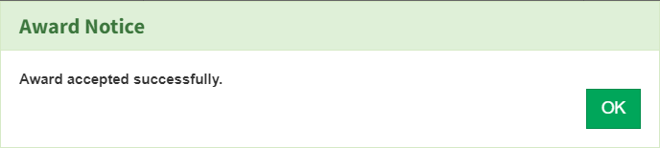

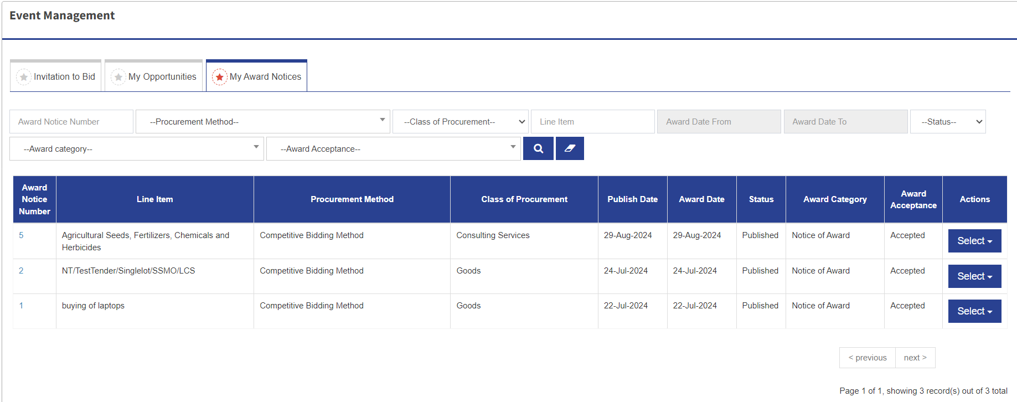**Step 8:** Click OK and the system redirects to the event management page with Award notice marked as Accepted.

**Step 9:** After accepting the Award, now the Supplier can Logout waiting for the contract.

……………………………………………………………………The End……………………………………………………………………..